EXTRAORDINARY MEETING of Municipal Council held by open videoconference at 6:00.m

PRESENT are the following Councillors:

|  |  |  |  |
| --- | --- | --- | --- |
| 1. | Michel DESROSIERS | 4. | Elizabeth FEE |
| 2. | Nathalie MEUNIER | 5. | David WILSON |
| 3. | Sophie BRASIOLA | 6. | Andrew J PELLETIER |

|  |
| --- |
| ABSENT(S) : |

|  |
| --- |
| QUORUM is present with Mayor Marcella Davis-Gerrish presiding. |

ALSO PRESENT are Benoit Tremblay, Director-General and Secretary-Treasurer, and Bruno Bélisle, Assistant Director-General

**Notice of the meeting was served, as required by law, to the Council members who are not present at the opening of the meeting.**

**SWEARING IN OF COUNCIL MEMBERS.**

The President of elections, Bruno Bélisle and the Director General and Secretary-treasurer and Commissioner of oaths, Benoit Tremblay, proceeded with the swearing in of the newly elected council members present, namely :

Ms Marcella DAVIS-GERRISH, Mayor

Councillors Michel DESROSIERS, seat 1

Nathalie MEUNIER, seat 2

Sophie BRASIOLA, seat 3

Elizabeth FEE, seat 4

David WILSON, seat 5

Andrew PELLETIER, seat 6

|  |  |  |
| --- | --- | --- |
| **Agenda** | | |
| 1. | 1. | Adoption of the Agenda |  |
|  | 2. | Question Period |  |
| 2. | 3. | Appointment of elected officials to the various boards |  |
|  | 4. | |  | | --- | | Approval of Accounts Payable | |  |
|  | 5. | Borrowing by-laws — Auction of an Issue of bonds |  |
|  | 6. | Borrowing by-laws – Issue of bonds and Short Term |  |
|  | 7. | Meeting Adjourned |  |

1. **ADOPTION of the agenda**

I, Elizabeth FEE, PROPOSE

THAT the agenda be adopted by combining the previous item 7 with item 6.

PASSED

1. **QUESTION PERIOD**

|  |  |  |
| --- | --- | --- |
| **CITIZEN** |  | **ISSUE** |
|  | Q |  |
| R |  |
|  | Q |  |
| R |  |
|  | Q |  |
| R |  |

1. **Appointment of the elected officials to the various boards**

WHEREAS the Municipality is a member of various Boards

WHEREAS it is necessary to appoint the delegated council members for

* The Régie Intermunicipale des Eaux Massawippi (RIEM)
* The Régie du Parc Régional Massawippi (RPRM);
* The Régie intermunicipale de prévention et de protection incendie Memphrémagog Est (RIPPIME);
* The Régie intermunicipale de gestion des déchets solides de la région de Coaticook (RIGDSC);
* The council of mayors of the Memphremagog MRC.

I, NATHALIE MEUNIER, MOVE

TO appoint Marcella DAVIS-GERRISH, Andrew J PELLETER and David WILSON as delegates to the RIEM;

TO appoint Marcella DAVIS-GERRISH as delegate to the RPRM;

TO appoint Marcella DAVIS-GERRISH as a delegate to the RIPPIME;

To appoint Elizabeth FEE as a delegate to the RIGDSC;

And to appoint Michel DESROSIERS as pro mayor to the council of mayors of the Memphremagog MRC.

PASSED

1. **Approval of accounts payable**

I, MICHEL DESROSIERS, MOVE

TO accept the payment of accounts payable as per the list submitted by the Treasury Department on November 1st , in the amount of $155,727.35, including all accounts over $5,000.00, as per list below:

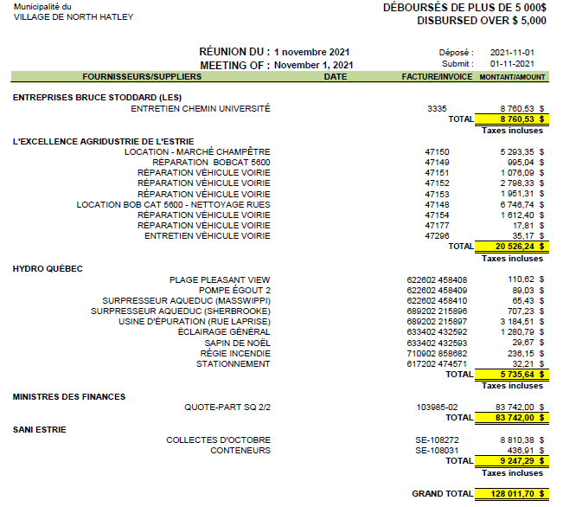

PASSED

1. **borrowing by-laws – auction of an issue of bonds**

WHEREAS, in accordance with Borrowing By-laws 2005-492, 2004-479, 2007-515, 2009-531 and 2021-635, the Municipality of the Village of North Hatley wishes to issue a series of bonds, one bond per maturity;

WHEREAS, the Municipality of the Village of North Hatley has requested, in this regard, through the electronic system "Municipal Finance Auction and Publication Service", bids for the sale of a bond issue, dated December 2, 2021, in the amount of $2,588,000

WHEREAS following this request, The Municipality of the Village of North Hatley received three compliant bids, all in accordance with Section 555 of the Cities and Towns Act (R.R.S.Q., Chapter C 19) or Section 1066 of the Quebec Municipal Code (R.R.S.Q., Chapter C 27.1), and the resolution adopted pursuant to this section.

|  |  |  |  |  |  |
| --- | --- | --- | --- | --- | --- |
| **Bidder** | **Price offered** | **Amount** | **Rates** | **Maturity** | **Real Cost** |
| VALEURS MOBILIÈRES BANQUE LAURENTIENNE INC. | 98,84928 | 424 000 $ | 0,85000 % | 2022 | 2,08604 % |
| 432 000 $ | 1,20000 % | 2023 |
| 441 000 $ | 1,55000 % | 2024 |
| 450 000 $ | 1,80000 % | 2025 |
| 841 000 $ | 1,95000 % | 2026 |
| VALEURS MOBILIÈRES DESJARDINS INC. | 98,58500 | 424 000 $ | 1,00000 % | 2022 | 2,13646 % |
| 432 000 $ | 1,30000 % | 2023 |
| 441 000 $ | 1,60000 % | 2024 |
| 450 000 $ | 1,75000 % | 2025 |
| 841 000 $ | 1,85000 % | 2026 |
| FINANCIÈRE BANQUE NATIONALE INC. | 98,46200 | 424 000 $ | 0,80000 % | 2022 | 2,24372 % |
| 432 000 $ | 1,25000 % | 2023 |
| 441 000 $ | 1,60000 % | 2024 |
| 450 000 $ | 1,80000 % | 2025 |
| 841 000 $ | 2,00000 % | 2026 |

WHEREAS the result of the calculation of the actual costs indicates that the bid submitted by the firm VALEURS MOBILIÈRES BANQUE LAURENTIENNE INC. is the most advantageous;

I, DAVID WILSON, MOVE

THAT the preamble to this resolution be and is hereby made a part of this resolution as if it were set out in full;

THAT the bond issue of the Municipality of the Village of North Hatley in the amount of $2,588,000 be awarded to VALEURS MOBILIÈRES BANQUE LAURENTIENNE INC;

THAT an application be made to the latter to mandate Service de dépôt et de compensation CDS inc. (CDS) for the book-entry of this issue;

THAT CDS act on behalf of its participants as Book-Entry Agent, Bond Agent, Paying Agent and as agent responsible for the transactions to be carried out in respect of its participants

THAT CDS proceed with the transfer of funds in accordance with the legal requirements of the bond, to this effect, Council authorizes the General Manager and Secretary-Treasurer to sign the document required by the Canadian banking system entitled "Authorization for the Pre-Authorized Debit Plan for Business";

That the Mayor and the Director General and Secretary Treasurer be authorized to sign the bonds covered by this issue, one bond per maturity.

PASSED

1. **borrowing by-laws – issue of bonds and short term**

WHEREAS, in accordance with the following borrowing by-laws and for the amounts indicated opposite each of them, the Municipality of the Village of North Hatley wishes to issue a series of bonds, one bond per maturity, for a total amount of $2,588,000 to be realized on December 2, 2021, distributed as follows

|  |  |
| --- | --- |
| **Borrowing by-law #** | **For an amount of $** |
| 2005‑492 | 1 715 600 $ |
| 2004‑479 | 91 300 $ |
| 2007‑515 | 141 900 $ |
| 2009‑531 | 589 200 $ |
| 2021‑635 | 50 000 $ |

WHEREAS it is necessary to amend the borrowing by-laws accordingly

WHEREAS, in accordance with the 1st paragraph of section 2 of the Municipal Debts and Loans Act (RLRQ, chapter D 7), for the purposes of this bond issue and for the borrowing by-laws number 2007 515 and 2009 531, the Municipality of the Village of North Hatley wishes to issue for a shorter term than that originally set out in these by-laws;

I, Andrew J PELLETIER, MOVE

THAT the borrowing by-laws indicated in the 1st paragraph of the preamble be financed by bonds, as follows

1.The bonds, one bond per maturity, shall be dated December 2, 2021;

2. Interest will be payable semi-annually on June 2 and December 2 of each year;

3. The bonds shall not be redeemable in advance; however, they may be redeemed with the consent of the holders in accordance with the Municipal Debts and Loans Act (R.S.Q., c. M-7)

4. The Bonds shall be registered in the name of Canadian Clearing and Depository Services Inc. ("CDS") and shall be deposited with CDS;

5. CDS will act on behalf of its participants as Book-Entry Agent, Bondholder Agent, Paying Agent and Transaction Agent for its participants;

6. CDS will effect the transfer of funds in accordance with the legal requirements of the Bond and to this end the Board authorizes the Executive Director and Secretary-Treasurer to execute the document required by the Canadian banking system entitled "Authorization for Corporate Pre-Authorized Debit Plan";

7. CDS shall make payments of principal and interest to Participants by electronic funds transfer and, for this purpose, CDS shall directly debit the required amounts from the following account

C.D. DU LAC MEMPHREMAGOG

230, RUE PRINCIPALE OUEST

MAGOG, QC

J1X 2A5

8. THAT the bonds be signed by the Mayor and the Secretary-Treasurer. The Municipality of the Village of North Hatley, as permitted by law, has authorized CDS to act as financial authenticator agent and the bonds will become effective only after they have been authenticated.

THAT, with regard to the annual capital amortizations planned for the years 2027 and following, the term provided for in borrowing by-laws 2007-515 and 2009-531 be shorter than the one originally set, i.e. for a term of five (5) years (starting December 2, 2021), instead of the term prescribed for said amortizations, each subsequent issue having to be for the balance or part of the balance due on the loan;

PASSED

1. **meeting adjourned**

At 6:19 p.m., all issues on the Agenda having been addressed

I, Nathalie MEUNIER, MOVE

THAT this meeting be adjourned.

PASSED

________________________ ___________________________

Marcella Davis-Gerrish Benoit Tremblay

Mayor Director-General

I, Marcella Davis-Gerrish, confirm that the signing of these Minutes is equivalent to the signing by me of all the resolutions contained herewith in accordance with Article 142 (2) of the Municipal Code.

This is not an official document. It has been translated from the French for information purposes only. In the event of a discrepancy between the French and the English documents, the French will prevail.